Running configuration 1/16

{'config': {'conv_layers': 1, 'filters': 32, 'dense_layers': 1, 'dense_units': 64, 'dropout': 0.2, 'epochs': 30, 'batch_size': 32, 'learning_rate': 0.001, 'activation': 'relu', 'optimizer': 'adam'}, 'test_accuracy': 0.9847715497016907, 'precision': 1.0, 'recall': 0.99425286, 'f1_score': 0.997118119271402, 'history': <keras.src.callbacks.History object at 0x000001B6A739A760>}

Running configuration 2/16

{'config': {'conv_layers': 1, 'filters': 32, 'dense_layers': 1, 'dense_units': 64, 'dropout': 0.2, 'epochs': 50, 'batch_size': 32, 'learning_rate': 0.001, 'activation': 'relu', 'optimizer': 'adam'}, 'test_accuracy': 0.9543147087097168, 'precision': 0.9942857, 'recall': 1.0, 'f1_score': 0.9971346646637115, 'history': <keras.src.callbacks.History object at 0x000001B6A70E2EE0>}

Running configuration 3/16

{'config': {'conv_layers': 1, 'filters': 32, 'dense_layers': 1, 'dense_units': 128, 'dropout': 0.2, 'epochs': 30, 'batch_size': 32, 'learning_rate': 0.001, 'activation': 'relu', 'optimizer': 'adam'}, 'test_accuracy': 0.9796954393386841, 'precision': 1.0, 'recall': 0.9885057, 'f1_score': 0.9942196400111626, 'history': <keras.src.callbacks.History object at 0x000001B6ABDA08B0>}

Running configuration 4/16

{'config': {'conv_layers': 1, 'filters': 32, 'dense_layers': 1, 'dense_units': 128, 'dropout': 0.2, 'epochs': 50, 'batch_size': 32, 'learning_rate': 0.001, 'activation': 'relu', 'optimizer': 'adam'}, 'test_accuracy': 0.9949238300323486, 'precision': 1.0, 'recall': 0.99425286, 'f1_score': 0.997118119271402, 'history': <keras.src.callbacks.History object at 0x000001B6ABF4BF10>}

Running configuration 5/16

{'config': {'conv_layers': 1, 'filters': 64, 'dense_layers': 1, 'dense_units': 64, 'dropout': 0.2, 'epochs': 30, 'batch_size': 32, 'learning_rate': 0.001, 'activation': 'relu', 'optimizer': 'adam'}, 'test_accuracy': 0.04568528011441231, 'precision': 0.88324875, 'recall': 1.0, 'f1_score': 0.9380053698493895, 'history': <keras.src.callbacks.History object at 0x000001B6ABE19FD0>}

Running configuration 6/16

{'config': {'conv_layers': 1, 'filters': 64, 'dense_layers': 1, 'dense_units': 64, 'dropout': 0.2, 'epochs': 50, 'batch_size': 32, 'learning_rate': 0.001, 'activation': 'relu', 'optimizer': 'adam'}, 'test_accuracy': 0.989847719669342, 'precision': 1.0, 'recall': 1.0, 'f1_score': 1.0, 'history': <keras.src.callbacks.History object at 0x000001B6AC020AF0>}

Running configuration 7/16

{'config': {'conv_layers': 1, 'filters': 64, 'dense_layers': 1, 'dense_units': 128, 'dropout': 0.2, 'epochs': 30, 'batch_size': 32, 'learning_rate': 0.001, 'activation': 'relu', 'optimizer': 'adam'}, 'test_accuracy': 0.9746192693710327, 'precision': 1.0, 'recall': 0.98275864, 'f1_score': 0.9913043582822514, 'history': <keras.src.callbacks.History object at 0x000001B6A71F9C70>}

Running configuration 8/16

{'config': {'conv_layers': 1, 'filters': 64, 'dense_layers': 1, 'dense_units': 128, 'dropout': 0.2, 'epochs': 50, 'batch_size': 32, 'learning_rate': 0.001, 'activation': 'relu', 'optimizer': 'adam'}, 'test_accuracy': 0.9847715497016907, 'precision': 1.0, 'recall': 0.99425286, 'f1_score': 0.997118119271402, 'history': <keras.src.callbacks.History object at 0x000001B6A70EB880>}

Running configuration 9/16

{'config': {'conv_layers': 2, 'filters': 32, 'dense_layers': 1, 'dense_units': 64, 'dropout': 0.2, 'epochs': 30, 'batch_size': 32, 'learning_rate': 0.001, 'activation': 'relu', 'optimizer': 'adam'}, 'test_accuracy': 0.9847715497016907, 'precision': 1.0, 'recall': 1.0, 'f1_score': 1.0, 'history': <keras.src.callbacks.History object at 0x000001B6A6FA88B0>}

Running configuration 10/16

{'config': {'conv_layers': 2, 'filters': 32, 'dense_layers': 1, 'dense_units': 64, 'dropout': 0.2, 'epochs': 50, 'batch_size': 32, 'learning_rate': 0.001, 'activation': 'relu', 'optimizer': 'adam'}, 'test_accuracy': 0.9796954393386841, 'precision': 1.0, 'recall': 0.99425286, 'f1_score': 0.997118119271402, 'history': <keras.src.callbacks.History object at 0x000001B6A9FC41C0>}

Running configuration 11/16

{'config': {'conv_layers': 2, 'filters': 32, 'dense_layers': 1, 'dense_units': 128, 'dropout': 0.2, 'epochs': 30, 'batch_size': 32, 'learning_rate': 0.001, 'activation': 'relu', 'optimizer': 'adam'}, 'test_accuracy': 0.9796954393386841, 'precision': 1.0, 'recall': 0.99425286, 'f1_score': 0.997118119271402, 'history': <keras.src.callbacks.History object at 0x000001B6ABD5D130>}

Running configuration 12/16

{'config': {'conv_layers': 2, 'filters': 32, 'dense_layers': 1, 'dense_units': 128, 'dropout': 0.2, 'epochs': 50, 'batch_size': 32, 'learning_rate': 0.001, 'activation': 'relu', 'optimizer': 'adam'}, 'test_accuracy': 1.0, 'precision': 1.0, 'recall': 1.0, 'f1_score': 1.0, 'history': <keras.src.callbacks.History object at 0x000001B6AA715940>}

Running configuration 13/16

{'config': {'conv_layers': 2, 'filters': 64, 'dense_layers': 1, 'dense_units': 64, 'dropout': 0.2, 'epochs': 30, 'batch_size': 32, 'learning_rate': 0.001, 'activation': 'relu', 'optimizer': 'adam'}, 'test_accuracy': 0.989847719669342, 'precision': 1.0, 'recall': 1.0, 'f1_score': 1.0, 'history': <keras.src.callbacks.History object at 0x000001B6A864F040>}

Running configuration 14/16

{'config': {'conv_layers': 2, 'filters': 64, 'dense_layers': 1, 'dense_units': 64, 'dropout': 0.2, 'epochs': 50, 'batch_size': 32, 'learning_rate': 0.001, 'activation': 'relu', 'optimizer': 'adam'}, 'test_accuracy': 0.9746192693710327, 'precision': 1.0, 'recall': 0.9770115, 'f1_score': 0.9883721266777993, 'history': <keras.src.callbacks.History object at 0x000001B702966460>}

Running configuration 15/16

{'config': {'conv_layers': 2, 'filters': 64, 'dense_layers': 1, 'dense_units': 128, 'dropout': 0.2, 'epochs': 30, 'batch_size': 32, 'learning_rate': 0.001, 'activation': 'relu', 'optimizer': 'adam'}, 'test_accuracy': 0.989847719669342, 'precision': 1.0, 'recall': 1.0, 'f1_score': 1.0, 'history': <keras.src.callbacks.History object at 0x000001B707C57A60>}

Running configuration 16/16

{'config': {'conv_layers': 2, 'filters': 64, 'dense_layers': 1, 'dense_units': 128, 'dropout': 0.2, 'epochs': 50, 'batch_size': 32, 'learning_rate': 0.001, 'activation': 'relu', 'optimizer': 'adam'}, 'test_accuracy': 0.9644669890403748, 'precision': 1.0, 'recall': 0.9885057, 'f1_score': 0.9942196400111626, 'history': <keras.src.callbacks.History object at 0x000001B6AABC8460>}

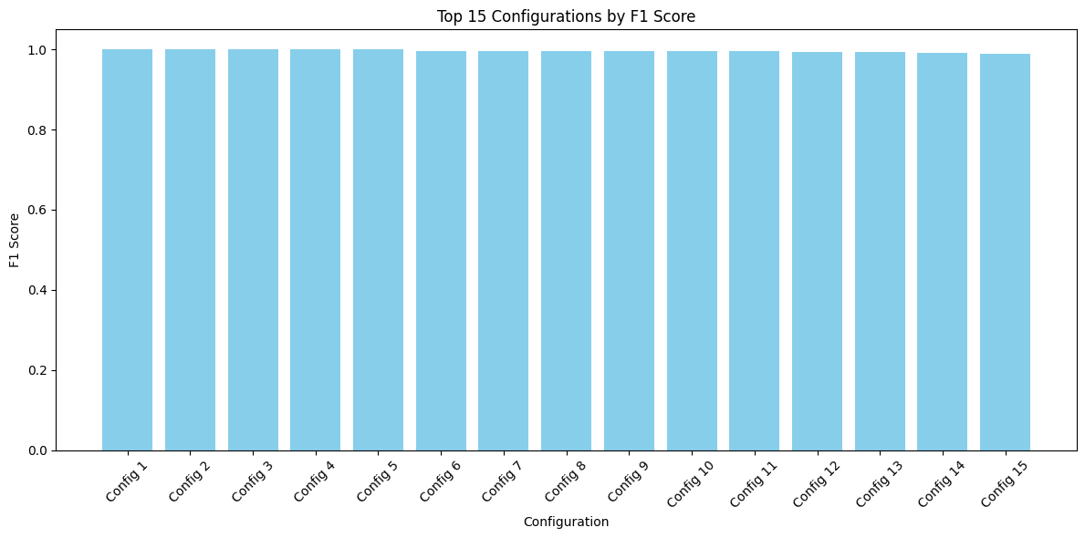

Training Configuration 1: {'conv_layers': 1, 'filters': 64, 'dense_layers': 1, 'dense_units': 64, 'dropout': 0.2, 'epochs': 50, 'batch_size': 32, 'learning_rate': 0.001, 'activation': 'relu', 'optimizer': 'adam'}

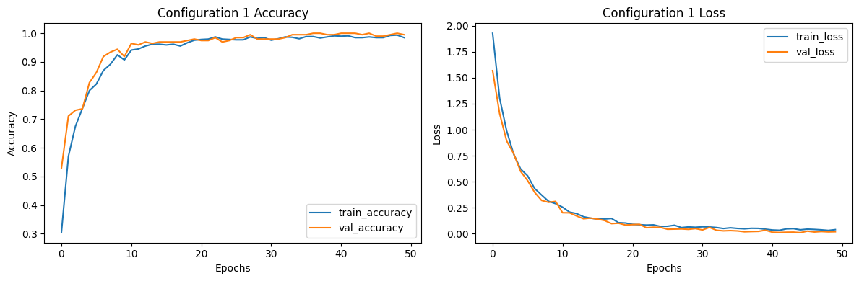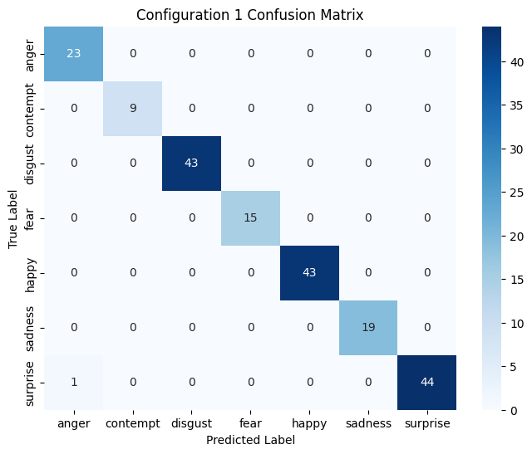Test Accuracy: 0.9949

Test Loss: 0.0190

Training Configuration 2: {'conv_layers': 2, 'filters': 32, 'dense_layers': 1, 'dense_units': 64, 'dropout': 0.2, 'epochs': 30, 'batch_size': 32, 'learning_rate': 0.001, 'activation': 'relu', 'optimizer': 'adam'}

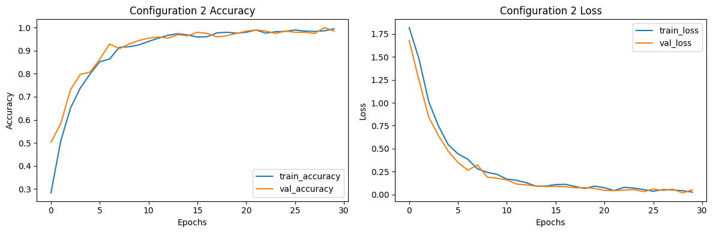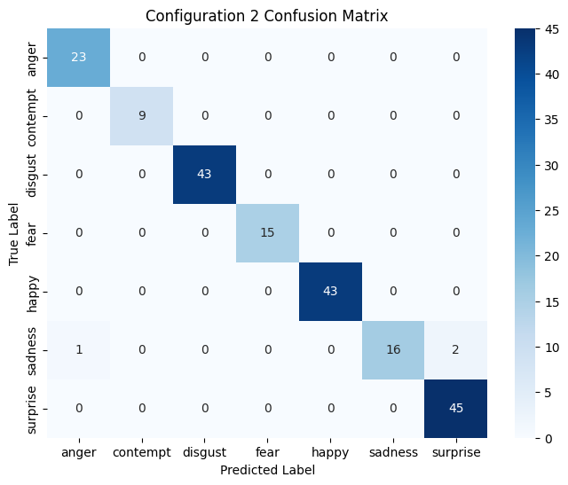Test Accuracy: 0.9848

Test Loss: 0.0524

Training Configuration 3: {'conv_layers': 2, 'filters': 32, 'dense_layers': 1, 'dense_units': 128, 'dropout': 0.2, 'epochs': 50, 'batch_size': 32, 'learning_rate': 0.001, 'activation': 'relu', 'optimizer': 'adam'}

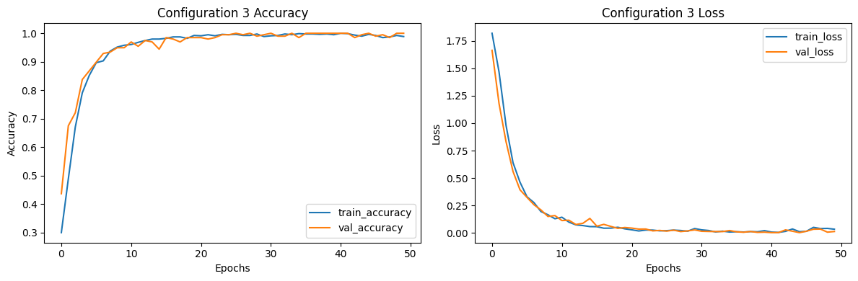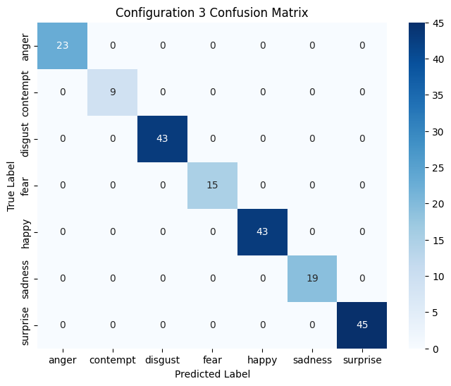Test Accuracy: 1.0000

Test Loss: 0.0143

Training Configuration 4: {'conv_layers': 2, 'filters': 64, 'dense_layers': 1, 'dense_units': 64, 'dropout': 0.2, 'epochs': 30, 'batch_size': 32, 'learning_rate': 0.001, 'activation': 'relu', 'optimizer': 'adam'}

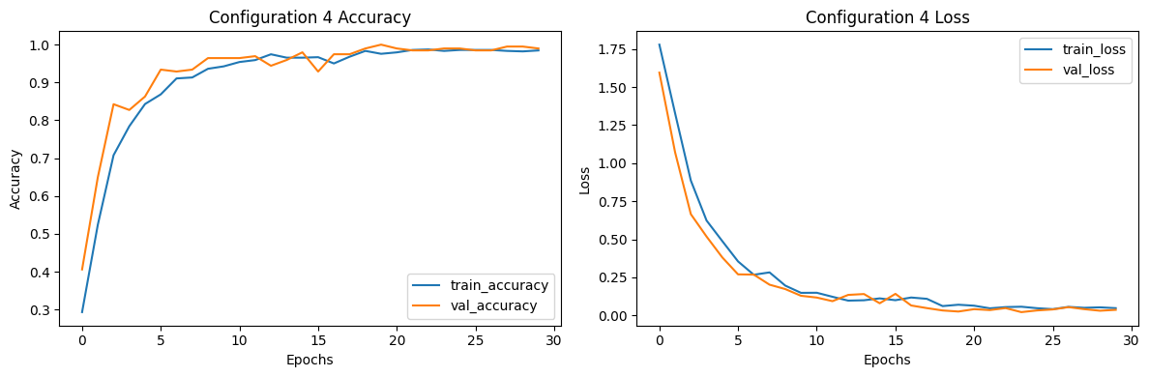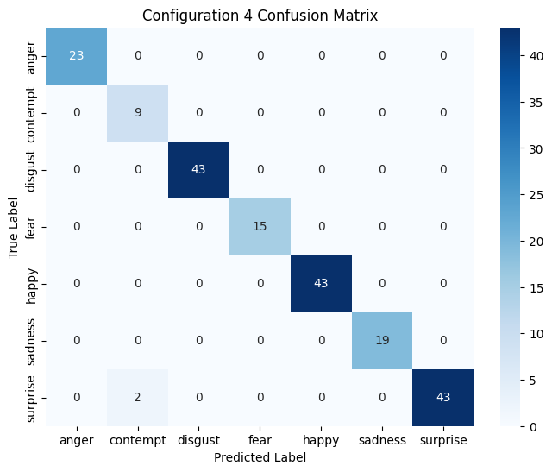Test Accuracy: 0.9898

Test Loss: 0.0365

Training Configuration 5: {'conv_layers': 2, 'filters': 64, 'dense_layers': 1, 'dense_units': 128, 'dropout': 0.2, 'epochs': 30, 'batch_size': 32, 'learning_rate': 0.001, 'activation': 'relu', 'optimizer': 'adam'}

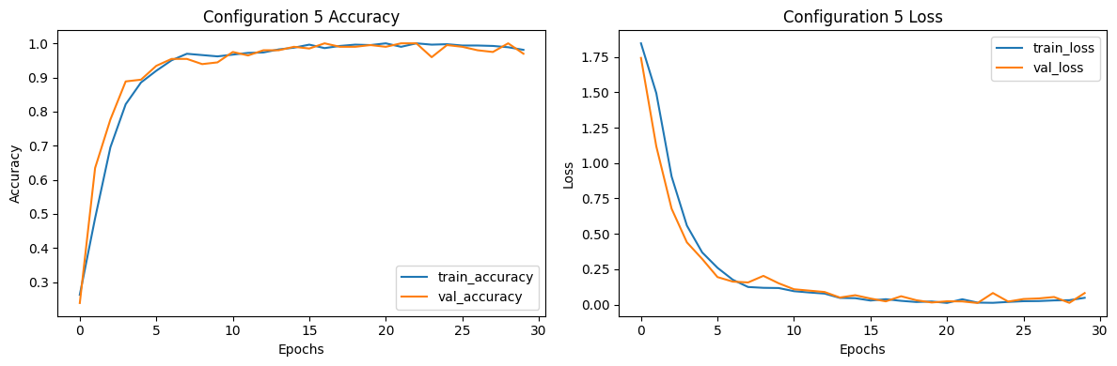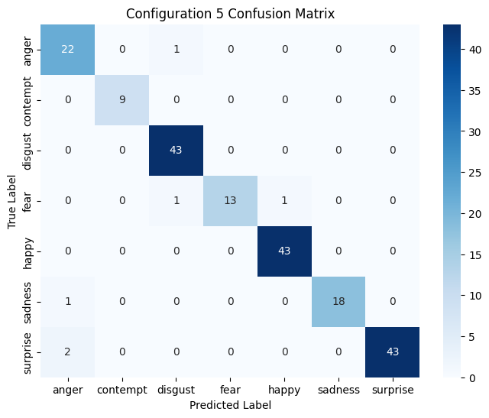Test Accuracy: 0.9695

Test Loss: 0.0819

|  |  |  |  |  |  |  |  |  |  |  |  |  |  |
| --- | --- | --- | --- | --- | --- | --- | --- | --- | --- | --- | --- | --- | --- |
| conv_layers | filters | dense_layers | dense_units | dropout | epochs | batch_size | learning_rate | activation | optimizer | Test Accuracy | Precision | Recall | F1 Score |
| 1 | 64 | 1 | 64 | 0.2 | 50 | 32 | 0.001 | relu | adam | 0.9898 | 1 | 1 | 1 |
| 2 | 32 | 1 | 64 | 0.2 | 30 | 32 | 0.001 | relu | adam | 0.9848 | 1 | 1 | 1 |
| 2 | 32 | 1 | 128 | 0.2 | 50 | 32 | 0.001 | relu | adam | 1 | 1 | 1 | 1 |
| 2 | 64 | 1 | 64 | 0.2 | 30 | 32 | 0.001 | relu | adam | 0.9898 | 1 | 1 | 1 |
| 2 | 64 | 1 | 128 | 0.2 | 30 | 32 | 0.001 | relu | adam | 0.9898 | 1 | 1 | 1 |
| 1 | 32 | 1 | 64 | 0.2 | 50 | 32 | 0.001 | relu | adam | 0.9543 | 0.9943 | 1 | 0.9971 |
| 1 | 32 | 1 | 64 | 0.2 | 30 | 32 | 0.001 | relu | adam | 0.9848 | 1 | 0.9943 | 0.9971 |
| 1 | 32 | 1 | 128 | 0.2 | 50 | 32 | 0.001 | relu | adam | 0.9949 | 1 | 0.9943 | 0.9971 |
| 1 | 64 | 1 | 128 | 0.2 | 50 | 32 | 0.001 | relu | adam | 0.9848 | 1 | 0.9943 | 0.9971 |
| 2 | 32 | 1 | 64 | 0.2 | 50 | 32 | 0.001 | relu | adam | 0.9797 | 1 | 0.9943 | 0.9971 |
| 2 | 32 | 1 | 128 | 0.2 | 30 | 32 | 0.001 | relu | adam | 0.9797 | 1 | 0.9943 | 0.9971 |
| 1 | 32 | 1 | 128 | 0.2 | 30 | 32 | 0.001 | relu | adam | 0.9797 | 1 | 0.9885 | 0.9942 |
| 2 | 64 | 1 | 128 | 0.2 | 50 | 32 | 0.001 | relu | adam | 0.9645 | 1 | 0.9885 | 0.9942 |
| 1 | 64 | 1 | 128 | 0.2 | 30 | 32 | 0.001 | relu | adam | 0.9746 | 1 | 0.9828 | 0.9913 |
| 2 | 64 | 1 | 64 | 0.2 | 50 | 32 | 0.001 | relu | adam | 0.9746 | 1 | 0.977 | 0.9884 |
|  |  |  |  |  |  |  |  |  |  |  |  |  |  |